 | Weekly Team Task Report | #6

Team: GeoLearn |  |  |  |  |  | Date: 2/23/2020
Project Title: Improving elementary education with custom online enironmental science lectures

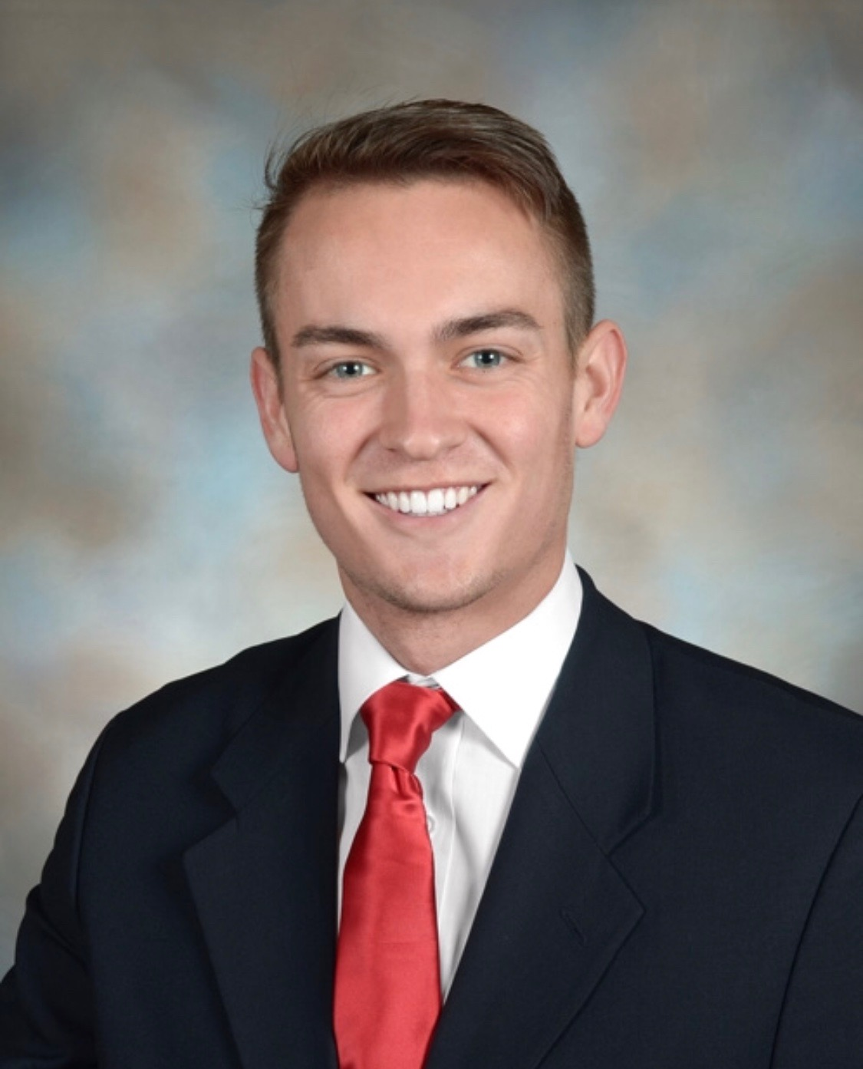 | Samuel Prassse  Present  On-time | 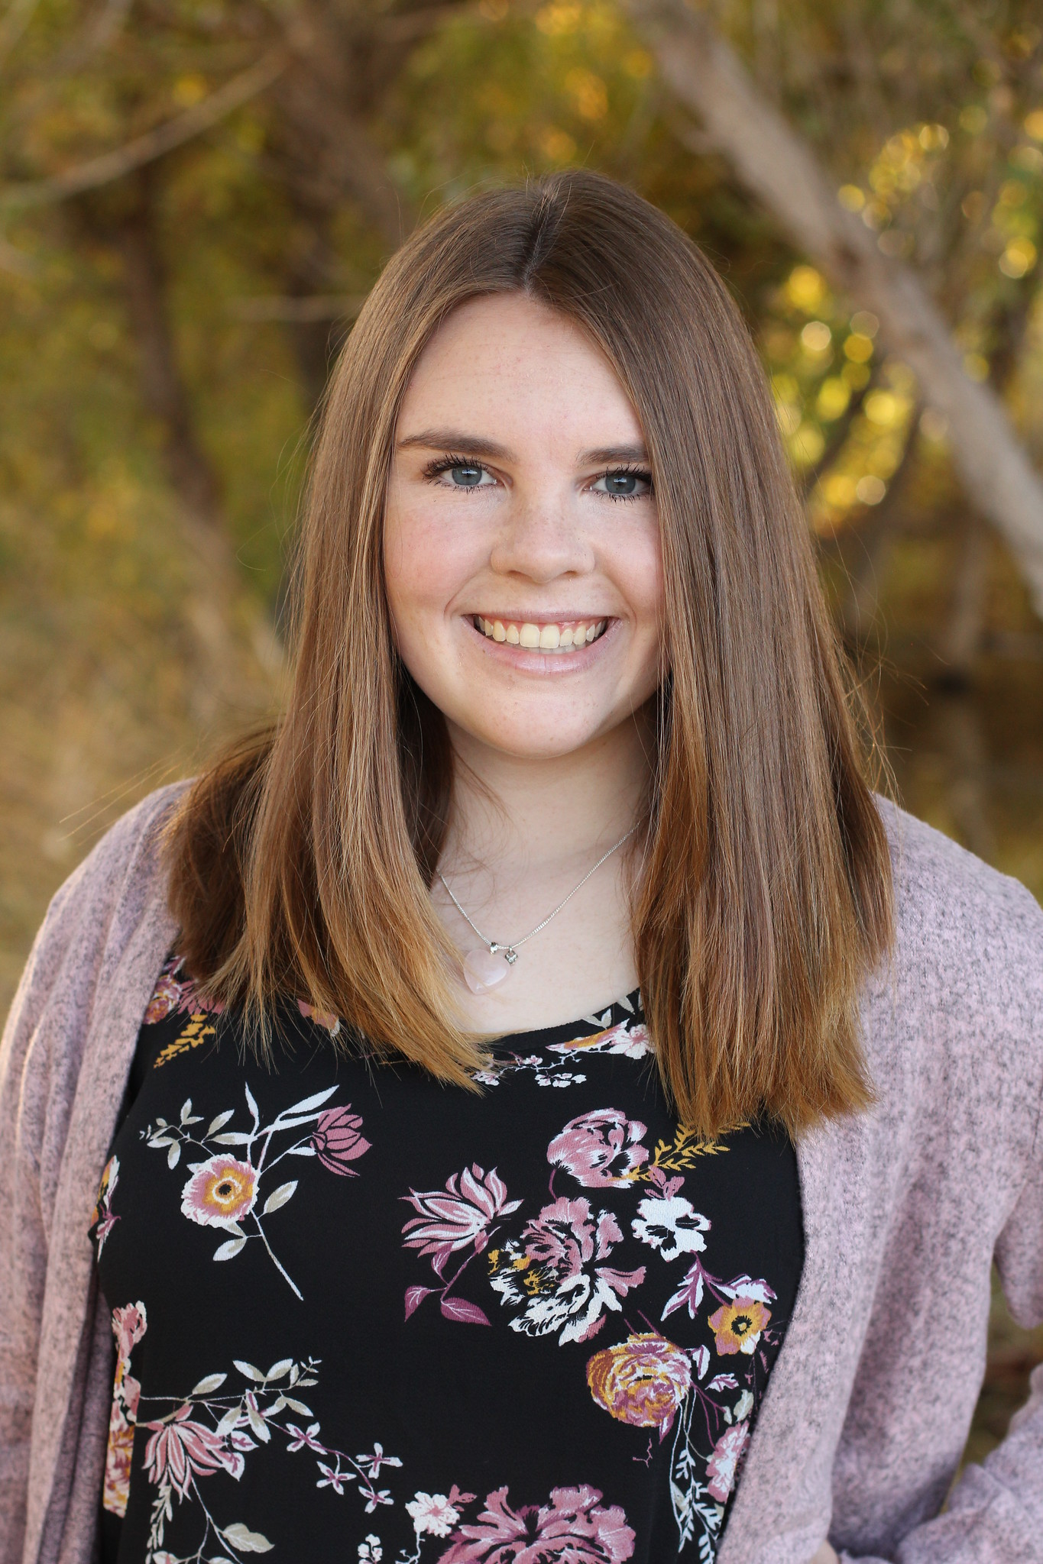 | Kaitlyn Grubb  Present  On-time | 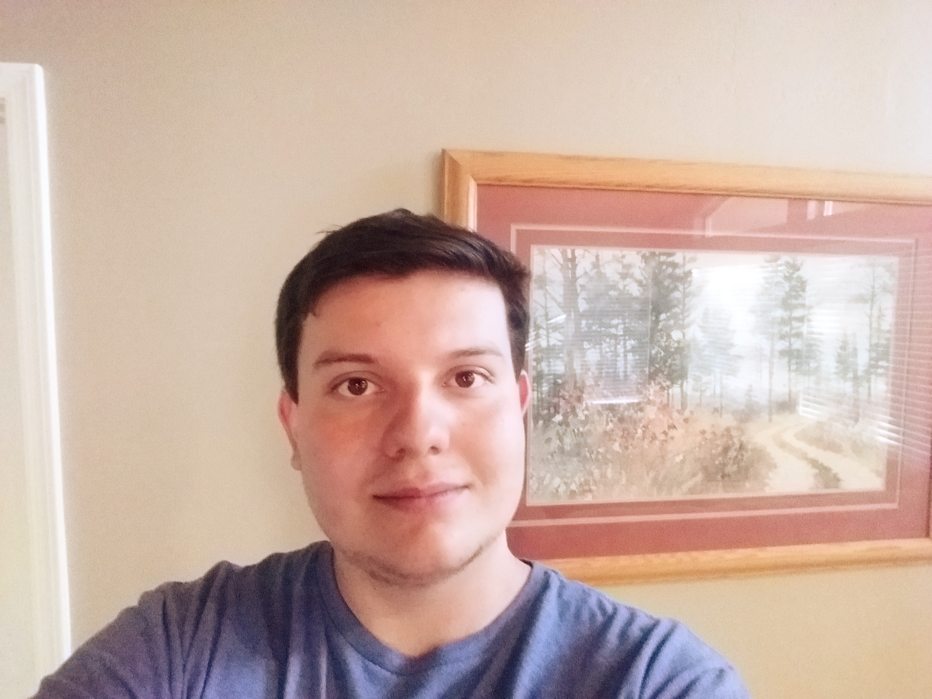 | Tyler Pehringer  Present  On-time |  | 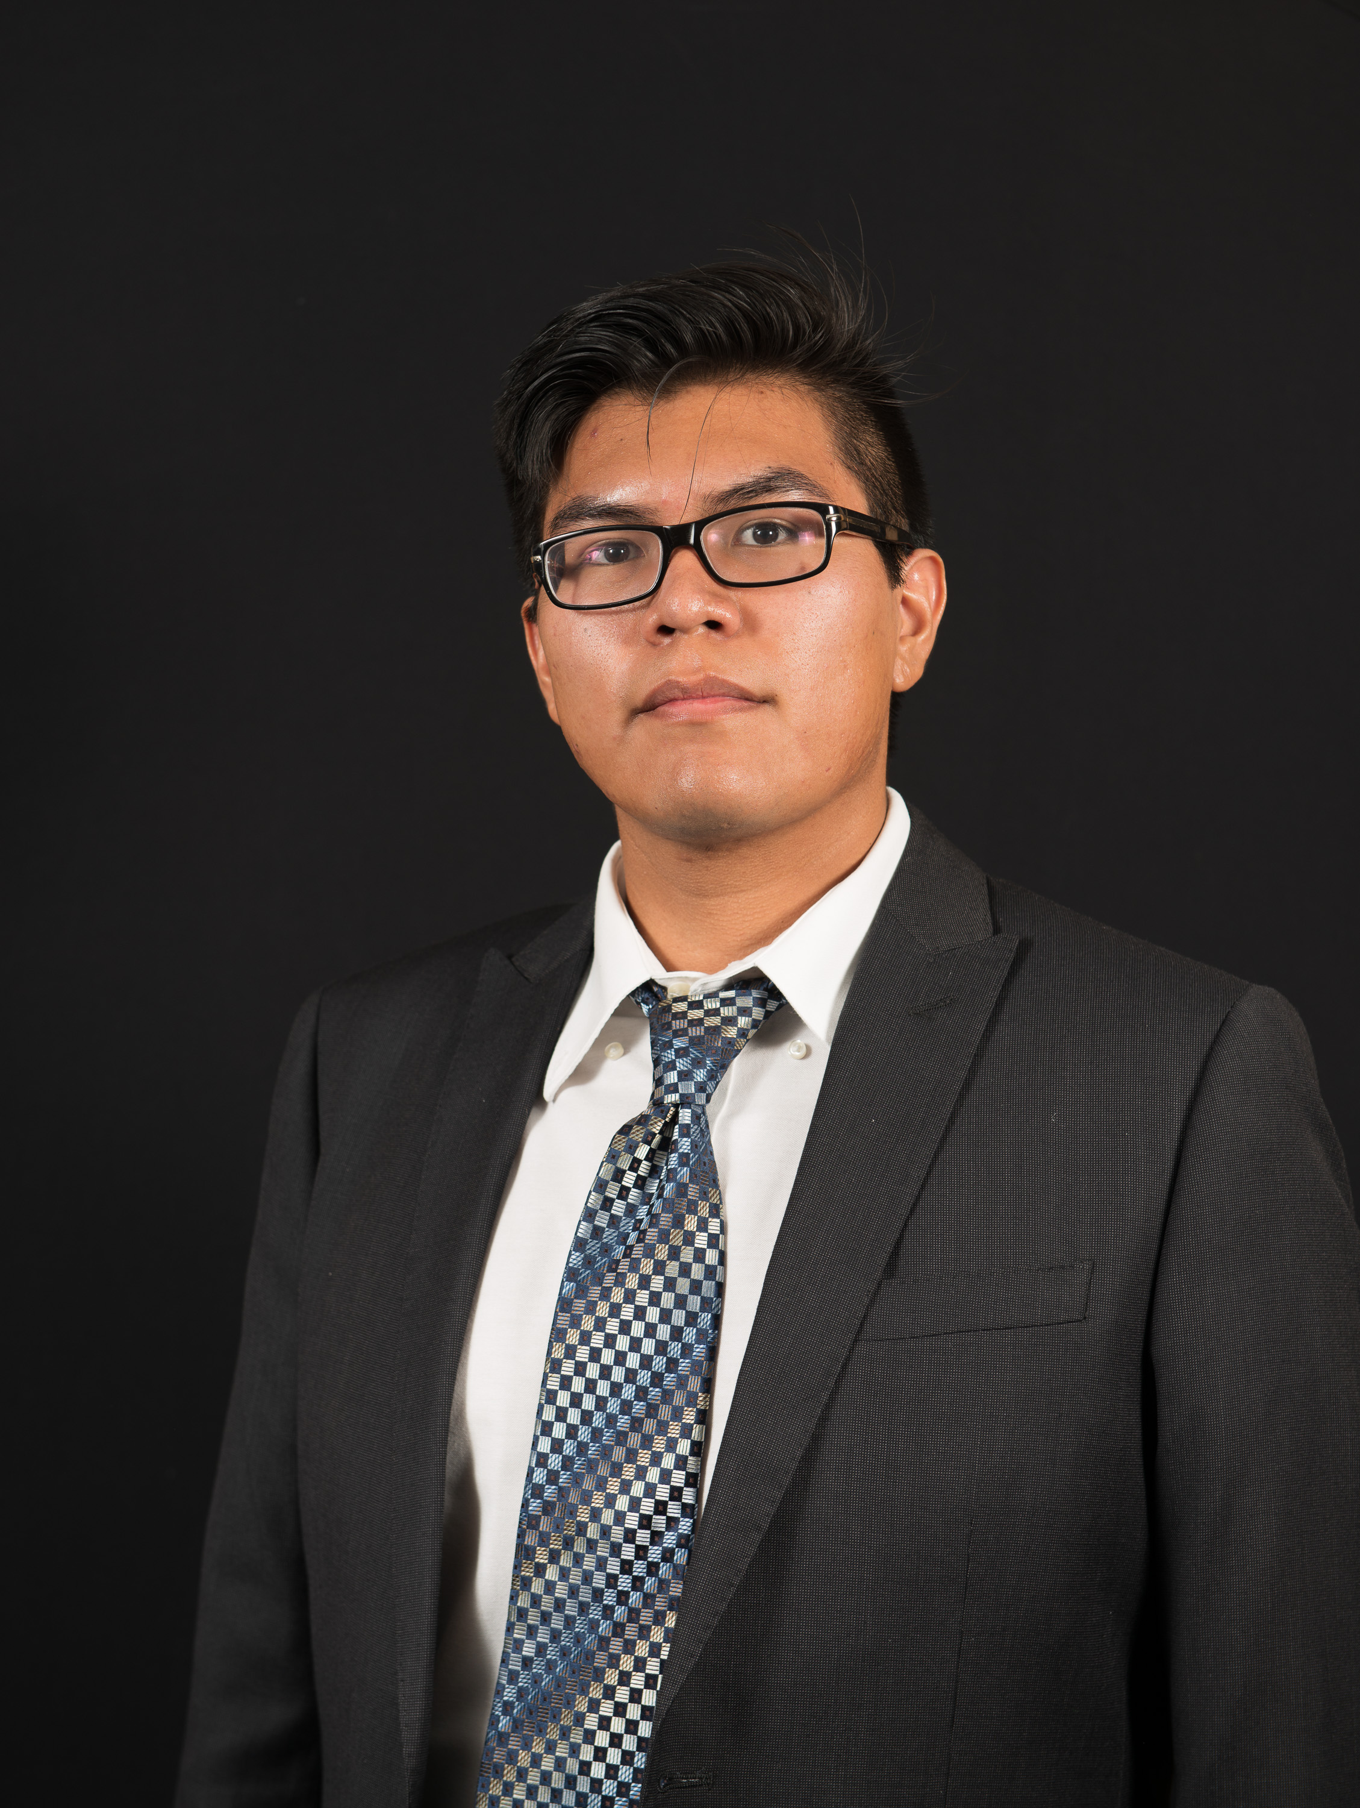 | Joshus Tenakhongva  Present  On-time

Recent Meetings:
- General Team Meeting
- Sponsor Meeting

TASKS COMPLETED since last meeting:

Task Title: UGRADS Registration | Task Initiation: 2/18 | Orig. Due Date: 2/21 | Status: 50% Completed
Who (%): Team (100%)
Description: The team will register for the Undergraduate Research and Design Symposium this week. This involves creating an abstract of our project, submitting it to Fabio for review, and then completing the application. The screenshot will be delivered to Fabio by this coming Friday 2/21.
Expected Outcome: Write an abstract for our project and complete UGRADS registration.

Task Title: Google Script Creation | Task Initiation: 2/18 | Orig. Due Date: 2/21 | Status: In Progress
Who (%): Joshus (100%)
Description: Joshus will be creating a python script that will draw images from Google image search based on the animals in the location as chosen by the user on the website. This will allow us to have pictures locally stored for ease of use in creating the presentations.
Expected Outcome: Getting correct and high quality images to our database.

Task Title: Combining Website Scripts | Task Initiation: 2/18 | Orig. Due Date: 2/21 | Status: In Progress
Who (%): Kaitlyn (100%)
Description: Kaitlyn will be combining the Python scripts the team has written to finalize the presentation creation process. This will happen by taking the input from the front end of the website, running the python scripts to gather the correct information and exporting a presntation to the user’s Google Drive.
Expected Outcome: Pressentation exportation with correct info.

Task Title: Exporting front end info to Python scripts | Task Initiation: 2/18 | Orig. Due Date: 2/21 | Status: In Progress
Who (%): Samuel (100%)
Description: Samuel will be taking user input from the front end of the website and then pass it to the previously written Python scripts for geo-specific information for the presentations. This is the precursor to Kaitlyn’s step this week as she will need this data to get the correct information in the slides.
Expected Outcome: Write an abstract for our project and complete UGRADS registration.

This week’s Tasks: Work plan for coming week
Task Title: Design Review 2 | Task Initiation: 2/18 | Orig. Due Date: 2/28 | Status: In Progress
Who (%): Team (100%)
Description: The team will be preparing and presenting our second Design Review to the Capstone faculty. Because of the stage we are in with our project, we will be able to showcase our website and database on AWS, and our slide creation methods as the “meat” of the presentation.
Expected Outcome: An excellent presentation that will blow the rest of the class away.

Upcoming Tasks: Planning
Task Title: Full Prototype Demo | Who (%): Team (100%) | Rough Due Date: 3/4
Description: At this point, the team will be presenting our full prototype to the capstone group.

Github Repo:
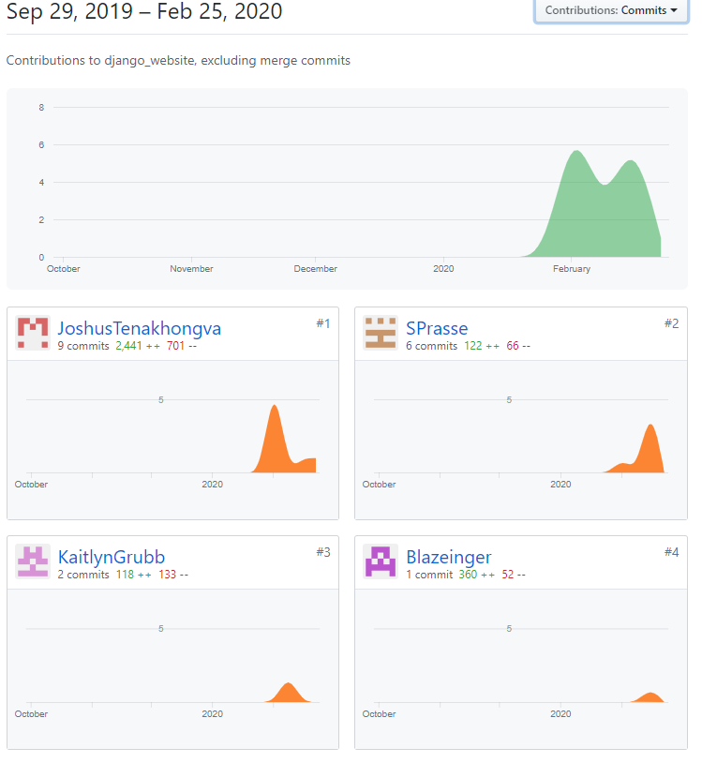

Schedule:

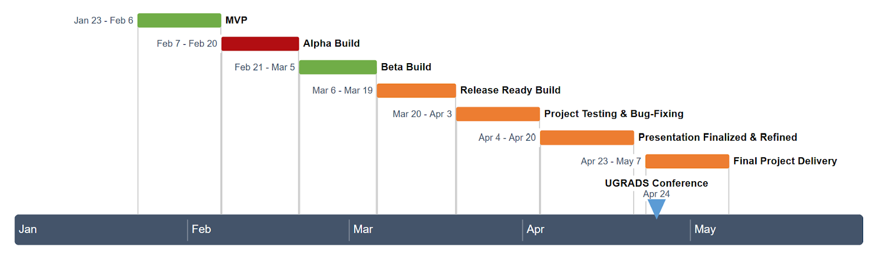

Other Problems / Other Issues:
- N/A

